**Python Calculator – Create A Simple GUI Calculator Using Tkinter:**

Hey python developers, in Python Calculator tutorial you will learn to create a simple GUI calculator. In this post I will show you how to develop a simple calculator using tkinter module in python. So let’s move further to create a simple python calculator.

Python offers a lot of options to develop GUI applications, but Tkinter is the most usable module for developing GUI (Graphical User Interface). Since Tkinter is cross-platform so **it works on both windows and Linux**. So here I am using Tkinter module to create a simple python calculator

## **Python Calculator Tutorial – Getting Started with Tkinter:**

The fastest and easiest way of developing GUI applications in python is working with Tkinter. So let’s took a quick look on Tkinter.

### **What is Tkinter:**

* The [**Tkinter**](https://docs.python.org/2/library/tkinter.html#module-Tkinter) module (“Tk interface”) is the standard Python interface to the Tk GUI toolkit.
* Both Tk and Tkinter are available on most Unix platforms, as well as on Windows systems.
* If you work on Linux/Ubuntu then you have to install Tkinter module on your machine for running programs, but on windows you don’t need to install it because it comes with the default python installation.

### Prerequisite for Python Calculator:

For developing a simple GUI calculator in python you must have to prior knowledge of following –

* [Tkinter](https://docs.python.org/2/library/tkinter.html)
* [Lambda](https://www.simplifiedpython.net/python-lambda-function/)

### Look of A Simple GUI Python Calculator:

Look at this calculator. Yup this is looking very cool. So now we have to create this calculator in python.

On this calculator we can perform following simple mathematical calculations –

* Multiplication
* Addition
* Subtraction
* Division

And now we will start writing codes for making this. To create this, we have to do four things –

* Importing Tkinter module.
* Creating the main interface (window for calculator).
* Adding any number of widgets to the main interface.
* Applying the event trigger on widgets.

### Creating Window For Calculator:

Let’s see the output.

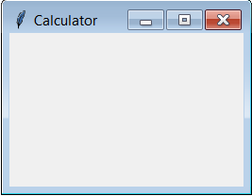

We have created this frame successfully, now lets move on ahead.

### Adding Display Widget:

So now the output is –

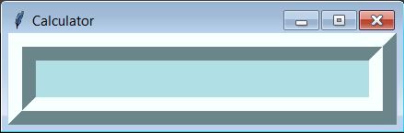

*

### Adding Clear Button Widget:

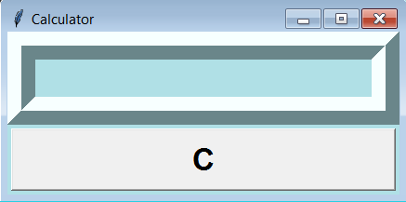

### Adding Numbers And Symbols Widget:

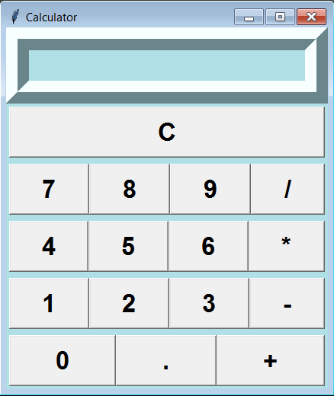

for calculator

### Adding Equal Button:

